|  |  |  |  |  |  |
| --- | --- | --- | --- | --- | --- |
| Date | 28-Nov-22 | | | Tester Name | Mayuri Patel |
| Environment | Penfax - Test | | | Login used |  |
| Operating System | Windows | Version: | Update: | | |
| Software Used | Edge | Version: | Update: | | |
| Not Applicable | Version: | Update: | | |
| Release version | 22.4.1 | | | | |
| Title | E11 Portability | | | | |
| Test Type | Regression | | | | |
| Test Scenario | E11.01 Process a portability Transfer out | | | | |
|  |  | | | | |
| Expected Results | Member’s investment account should have $0 and in inactive status.  Benefit Receipt should be generated under member’s account.  Cheque for the financial institute should be generated through payment batch.  Payment Confirmation and Member Withdrawal letters should be generated.  PEPP Valuation Report should show the transaction. | | | | |
| Pass/Fail | Pass | | | JIRA# | N/A |

Describe your steps with screenshots:

1. Bring up the deferred member in PENFAX5. Click on Member Profile. Click on Investments. Make sure the member has funds to transfer out.

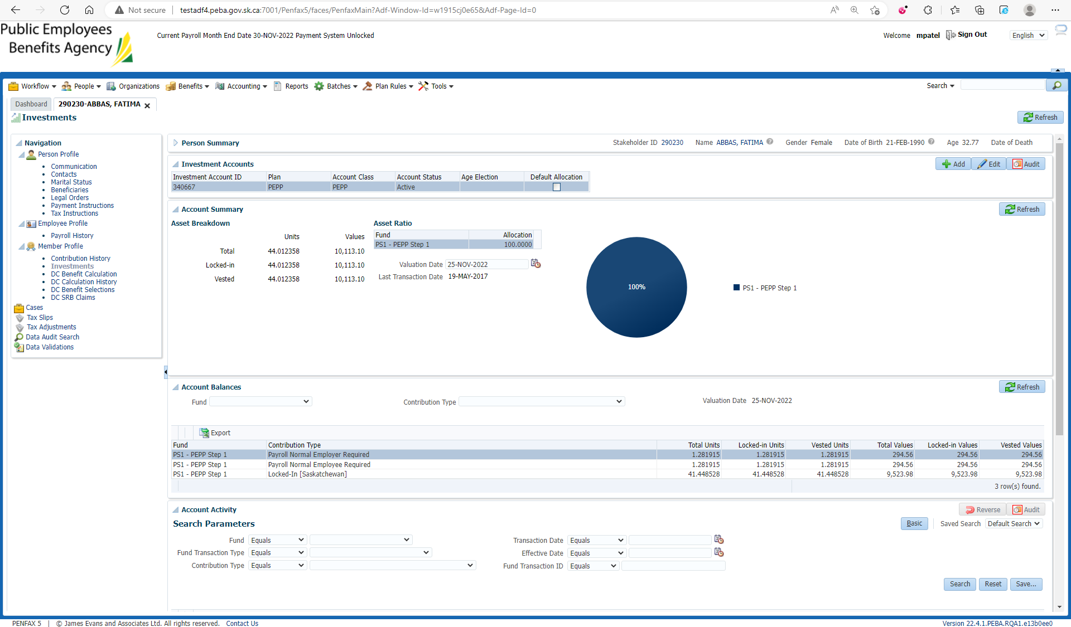

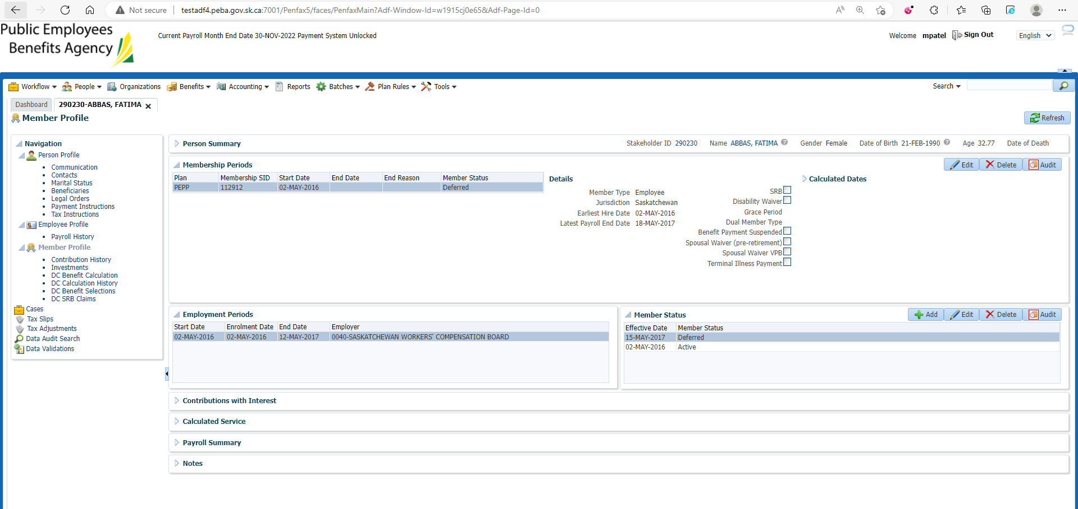

1. Click on DC Benefit Selections. Click Add. Make sure the Termination Date populates.

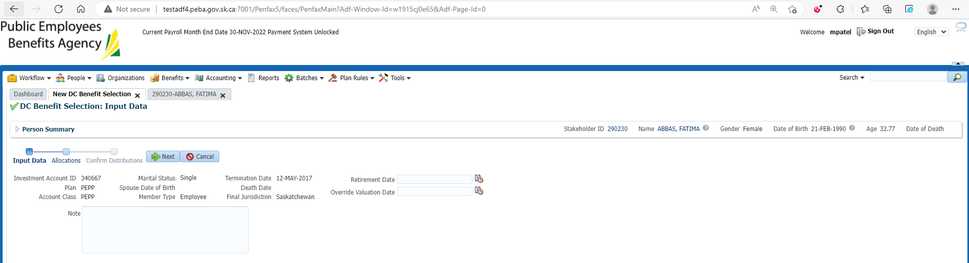

1. Click next and add the allocation for 100% of the member's account selecting "RPP" as the transfer vehicle. Repeat for each fund and contribution type.

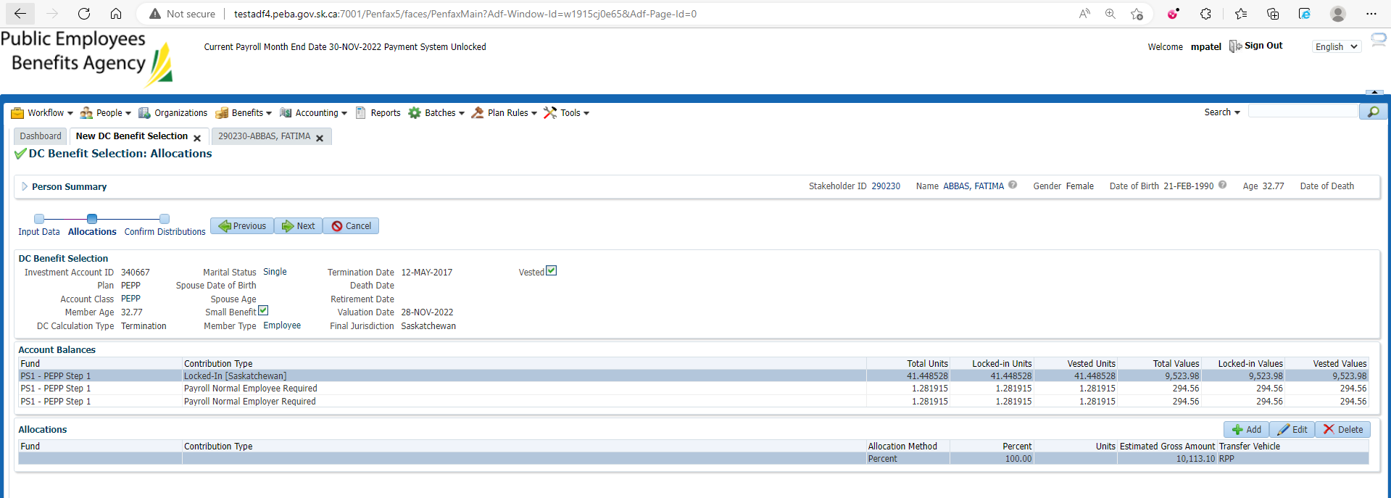

1. Click next and add the payment instructions for the institution that the member has elected to transfer their funds to and tax instruction and then click Submit for Approval.

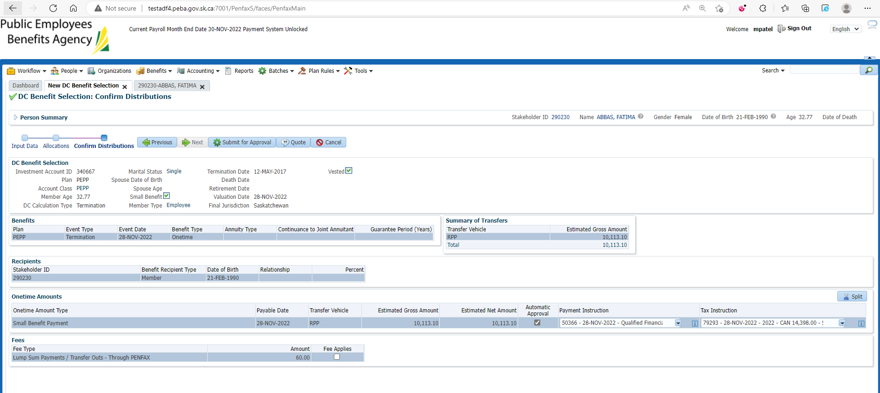

1. Approve the payment.

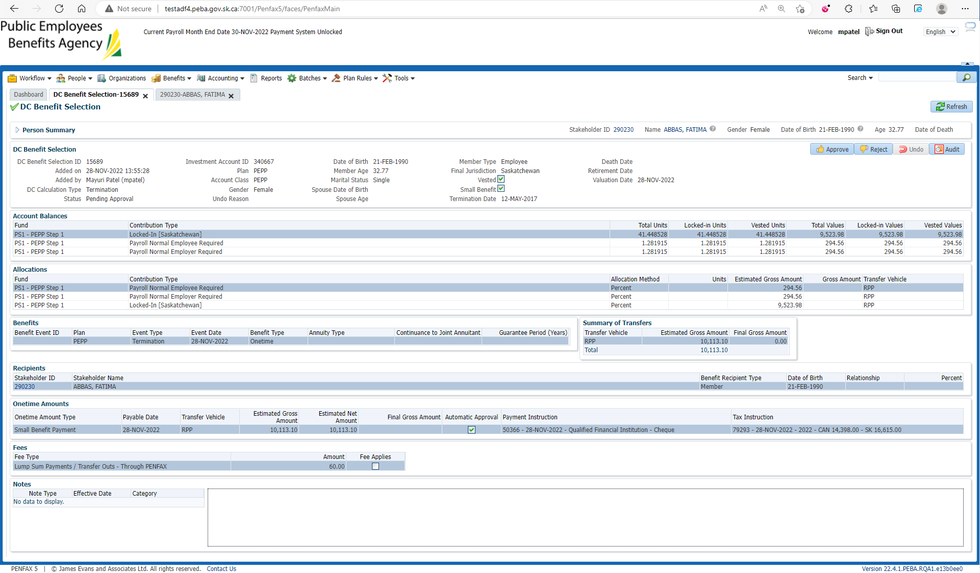

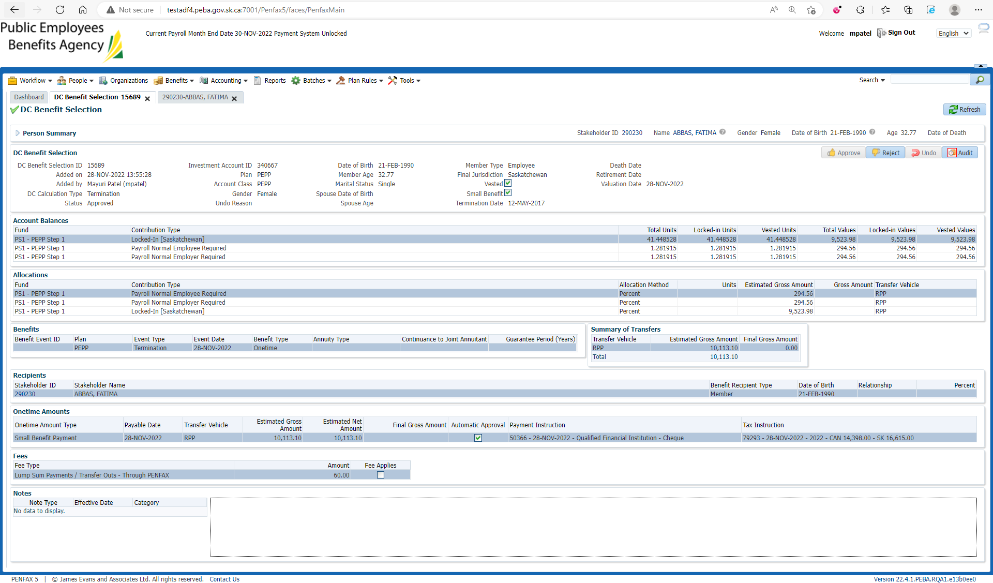

1. PIT batch will run overnight and prepare the payment for the payment production batch.

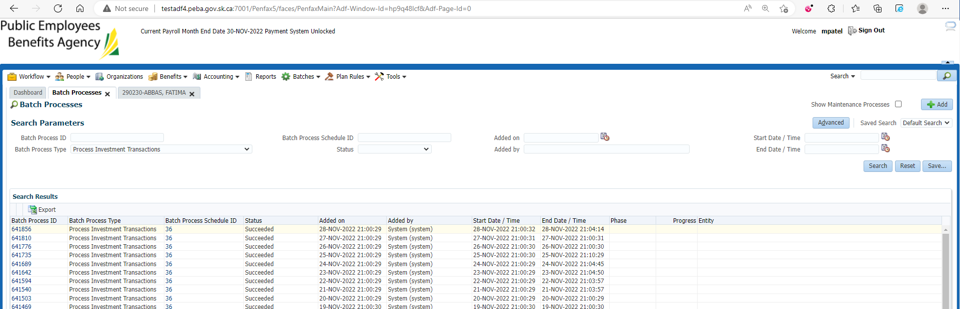

1. Process the payment through Payment Production.

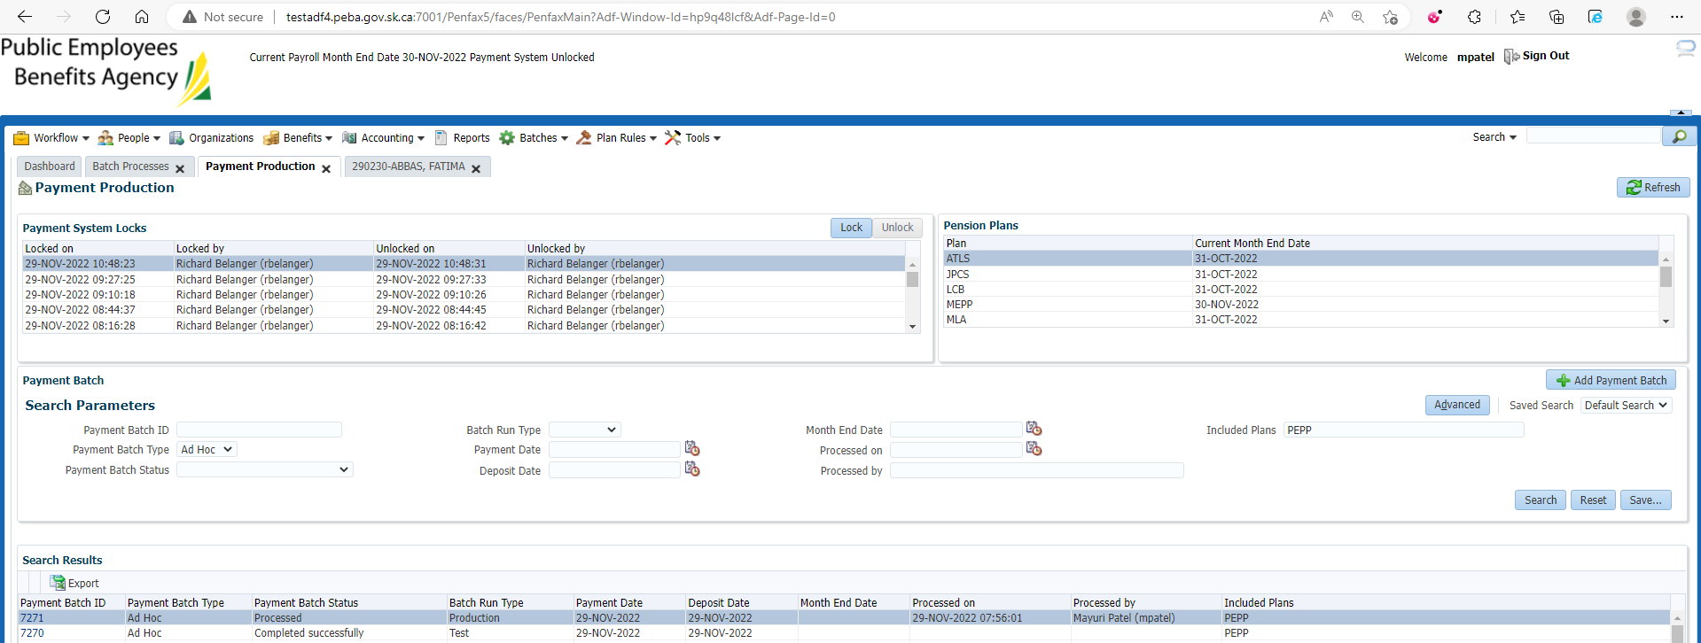

1. Click on that Payment Batch ID.

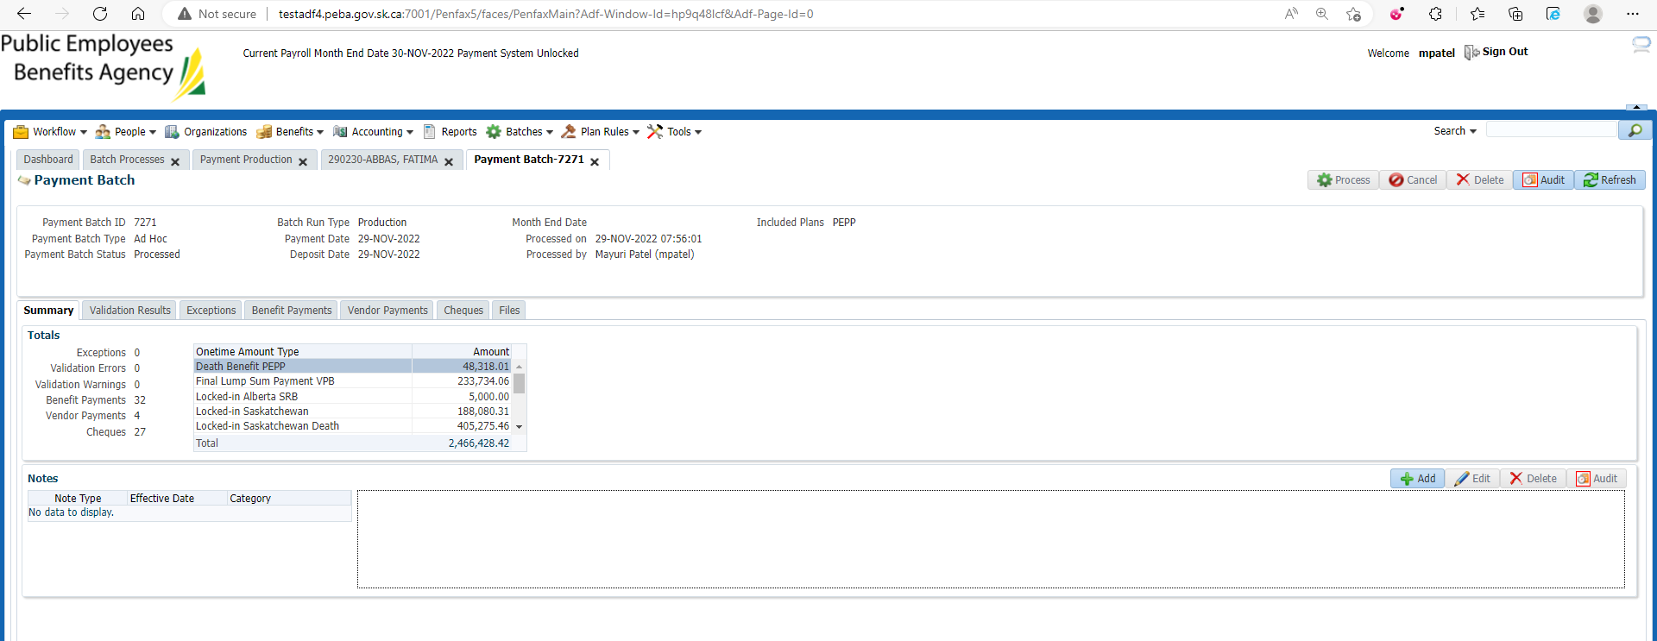

1. Go to Cheques tab.

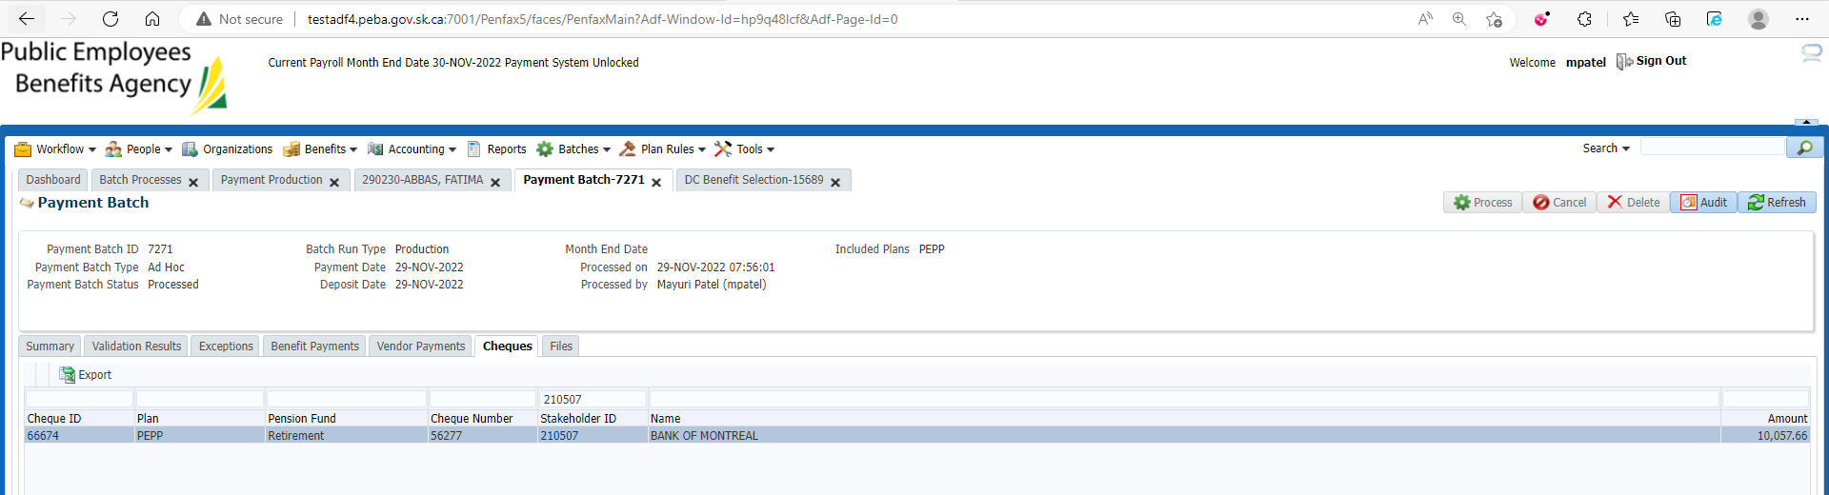

1. Click on Cheque ID to verify it.

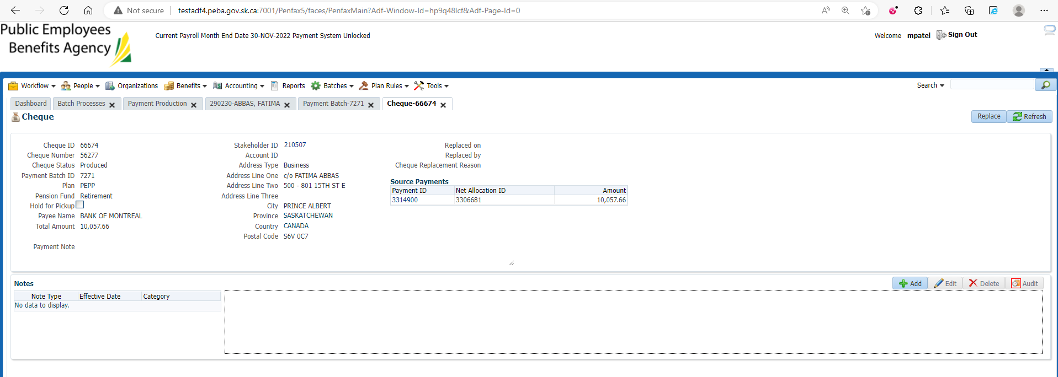

1. Verify that member’s investment account is now having $0 and inactive.

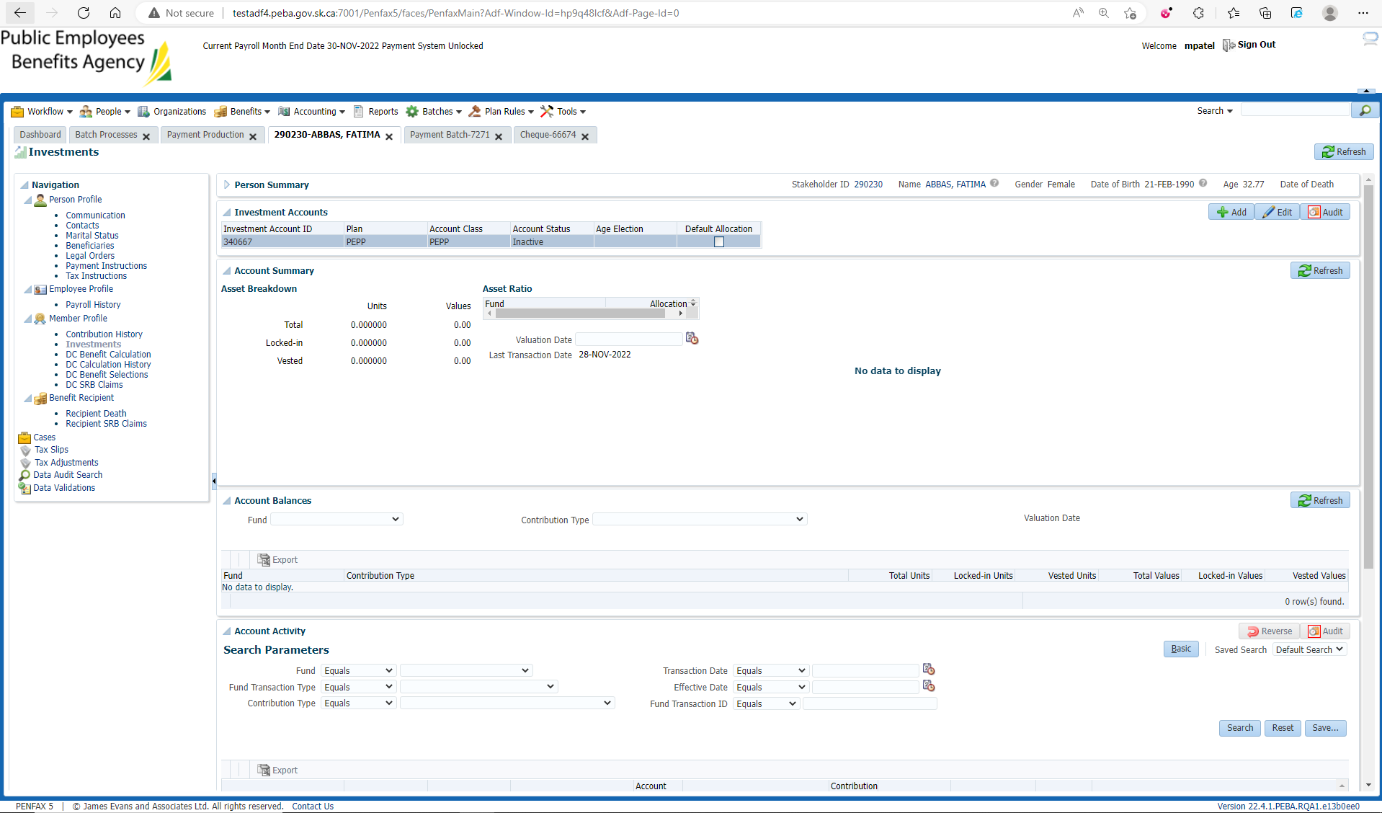

1. Go to Benefit Recipient tab and verify the benefit receipt.

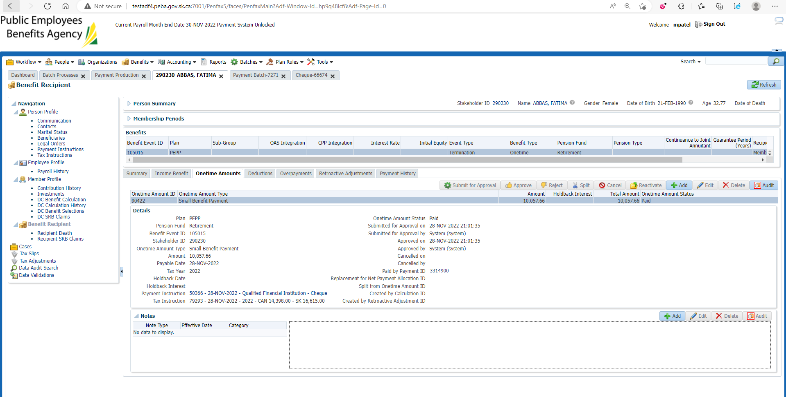

1. Go to Communication tab. Under Outbound documents, Payment Confirmation Letter and Member Withdrawal Letter should be generated.

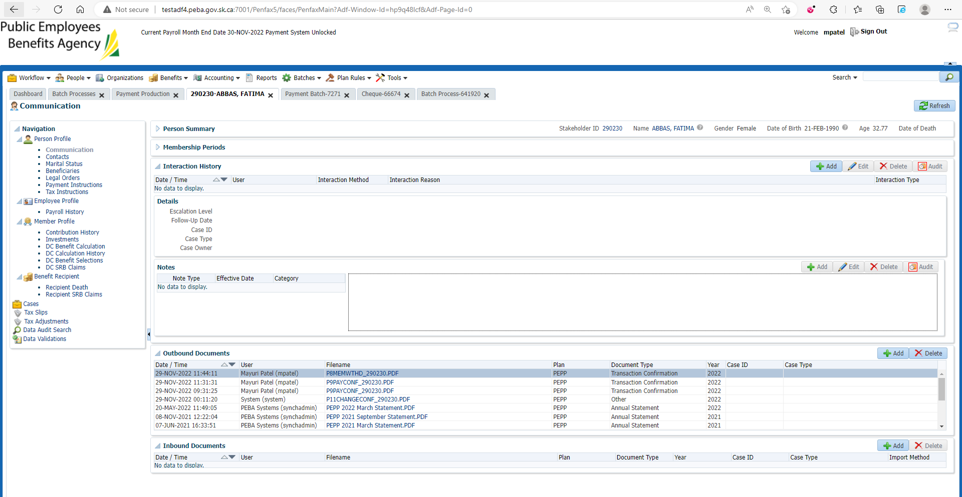

Payment Confirmation Letter

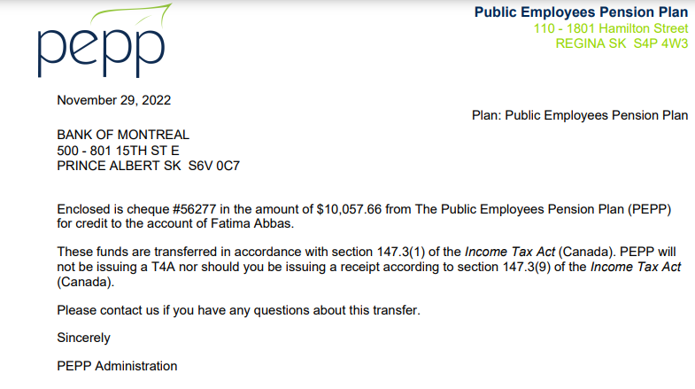

Member Withdrawal Letter

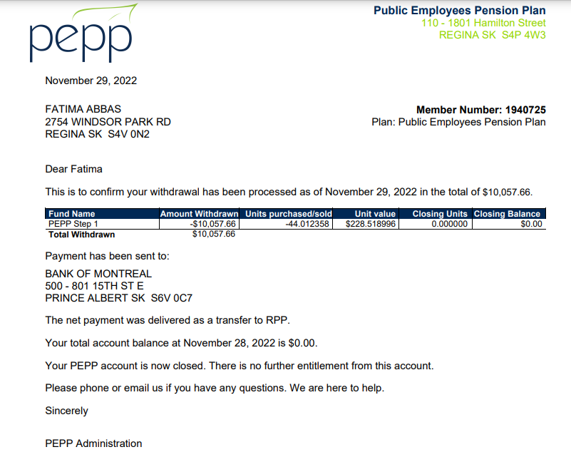

1. Go to Batches -> Batch Process and search for PEPP Valuation Report. Open the latest Valuation Report.

On Section Seven tab:

